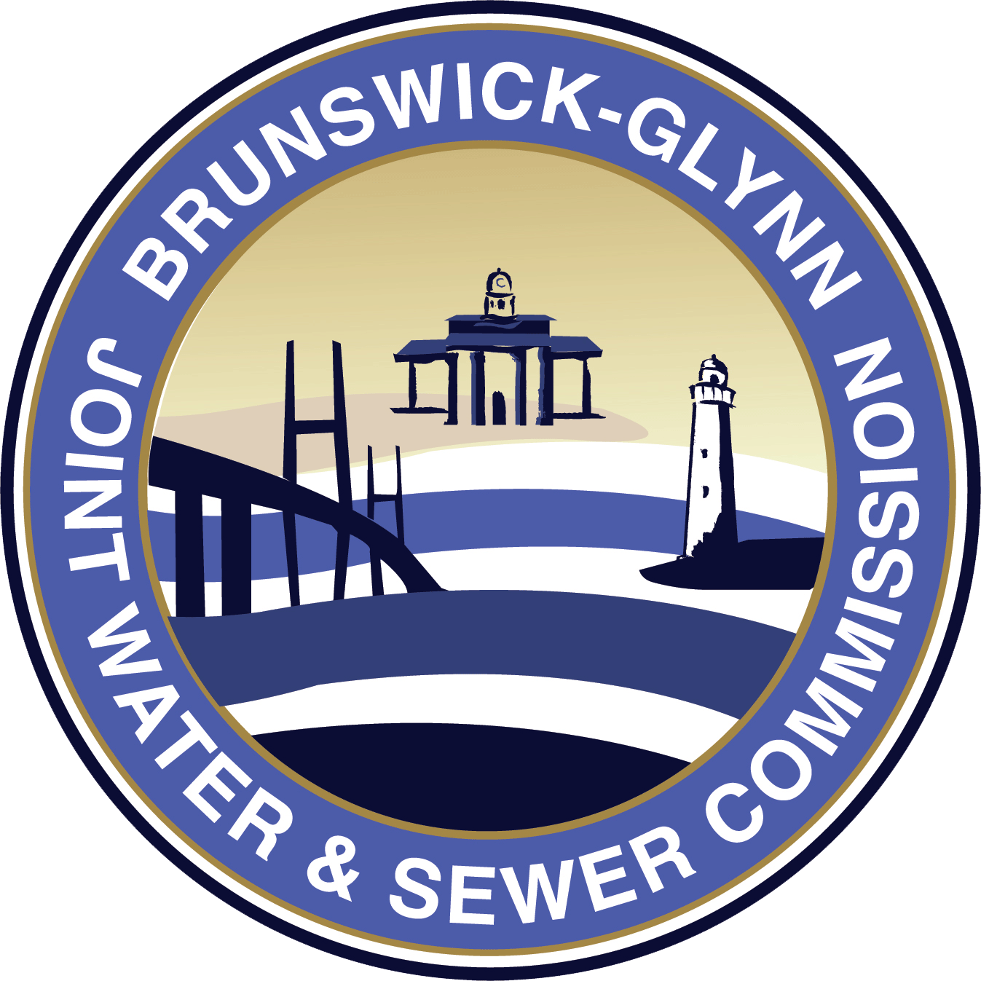

Brunswick-Glynn County
Joint Water and Sewer Commission

RFP No. 23-002
Request For Proposals

Three (3) Extended or Crew Cab Quarter-Ton 4x2 Pickup Trucks
for the
Brunswick-Glynn County Joint Water and Sewer Commission

Monday, July 18, 2022

Responses Due by:

12:00 NOON, EST Friday, July 29, 2022, to:

Purchasing Division
Joint Water and Sewer Commission
1703 Gloucester Street
Brunswick, Georgia 31520
(912) 261-7127

Submit responses in hard copy only; e-mail or fax responses will not be accepted.
Responses received after the deadline or at any other locations will not be accepted.

Deadline for questions is Thursday, July 21, 2022, no later than 3:00 p.m. EST.
Questions must be directed in writing (via e-mail) to the
Purchasing Director, Pamela Drury-Crosby, email- pcrosby@bgjwsc.org

FOR COMPLETE DETAILS OF THIS SOLICITATION, please visit the BGJWSC website, utilizing the following link:

http://www.bgjwsc.org/departments/procurement/

REQUEST FOR PROPOSALS
RFP No. 23-002

The Brunswick-Glynn County Joint Water and Sewer Commission (JWSC) is seeking proposals for three (3) 2022 or 2023 Crew or Extended Cab Quarter-Ton 4x2 Pickup Trucks. Responses Due by: 12:00 NOON, EST Friday, July 29, 2022, to: Purchasing Division, Joint Water and Sewer Commission, 1703 Gloucester Street, Brunswick, Georgia 31520. Please label the proposal submission with the following: RFP NO. 23-002 Three (3) - 2022 or 2023 Extended or Crew Cab Quarter Ton 4x2 Pickup Trucks.” The deadline for questions related to this solicitation is Thursday, July 21, 2022, no later than 3:00 p.m. EST. Please send questions via email to the Purchasing Director, Pam Crosby, via email at pcrosby@bgjwsc.org.

JWSC is soliciting proposals from Respondents qualified, responsible and willing to provide the following Goods and/or Services in compliance with all solicitation specification and requirements contained or referenced herein. The JWSC reserves the right to terminate the contract for any violation, by the successful proposer, of any term or condition of the contract by giving thirty (30) days written notice stating the reasons therefore and giving the party time to remedy any deficiencies. All proposal prices submitted must be guaranteed for ninety (90) days.

JWSC reserves the right to reject any and all proposals or parts of a proposal and waive technicalities, and to adjust quantities.

All proposals will be considered final. No additions, deletions, corrections, or adjustments will be accepted after the time of proposal opening.

All delivery costs or charges must be included in the F.O.B. destination proposal price.

City, County and State of Georgia Sales Tax and Federal Taxes are not applicable to sales made to JWSC and must be excluded.

The contract shall be effective for the approximate twelve (12) month period from the date of the notice of award.

The electronic version of this proposal/RFP is available upon request at the JWSC website: http://www.bgjwsc.org/departments/procurement/

Vendors are required to clearly identify any deviations from the specifications in this document.

An authorized officer of the company submitting the proposal must sign all proposals, in blue ink.
Vendors must submit two [2] signed copies of their proposal; one is to be an original and so marked plus (1) electronic copy on USB-drive.

All prices and notations must be in blue ink or typewritten on the attached form. Mistakes must be crossed out, corrections typed adjacent and must be initialed in blue ink by the person signing the proposal

Sealed proposals received after the designated time of the receipt of the sealed proposals will be considered as “No Proposal” and “Void” and will not be opened.

All proposers must possess the necessary and appropriate business and/or professional licenses in their field.

Award will be made to the low responsive, responsible proposer, or to the offeror whose proposal is most advantageous to the JWSC, price and other factors considered including geographic location. JWSC reserves the right to accept any item or group of items offered, unless the proposer qualifies his proposal by specific limitations. The proposal can be on an "all or none" basis if wording in the proposal so states and if all items solicited are included in the proposal.

PRODUCT SPECIFICATION

Solicitation Statement: JWSC is soliciting proposals from Respondents qualified, responsible and willing to provide the following Goods and/or Services in compliance with all solicitation requirements contained or referenced herein.

General Description: To provide JWSC with Fleet Vehicles as per specifications for herein. Unless otherwise specified, any manufacturers’ names, trade names, brand names, information and/or catalog numbers listed in this specification are descriptive, not restrictive. The proposer may offer any product that meets or exceeds the applicable specifications. The proposer must demonstrate comparability, by including appropriate catalog materials, literature, specifications, test data, etc. The JWSC shall determine in its sole discretion whether a product is acceptable as an equivalent.

Vehicle Description: JWSC anticipates purchasing a quantity of Three (3) 2022 or 2023 Crew Cab or Extended Cab Quarter-Ton 4x2 Pickup Trucks

Item Number | Feature | Features of Model Offered (check one)
Item Number | Feature | Meets Specification | Exceeds Specification | Does not meet Specification | Not Available
1 | 2.0L eco-boost / turbo-four Gasoline Engine
2 | Minimum GVWR of 6,010 lbs.
3 | Air Conditioning
4 | All Wheel Drive - AWD
5 | Automatic transmission with Overdrive (6-speed)
6 | Extended or Crew Cab
7 | Power Steering
8 | Heavy duty battery
9 | Vinyl seats
10 | Three sets of Keys
11 | Manufacturer’s standard AM/FM radio
12 | Four wheel anti-lock braking system (ABS)
13 | Driver & passenger front air bags
14 | Rubber flooring
15 | Auto locking hubs
16 | Bed size 8’
17 | All Season Tires with Full sized spare
 |  | Features of Model Offered (check one)
 |  | Meets Specification | Exceeds  Specification | Does not meet Specification |  | Not available
18 | Speed Control and Tilt wheel
19 | Three (3) year full warranty on entire unit (bumper to bumper)-minimum
20 | Heavy duty, minimum 4K capacity trailer package w/receiver hitch
21 | Mileage less than 500 miles at time of delivery to JWSC
22 | Delivery Date to JWSC location no later than 6/15/2023
OPTIONS
1. | Limited slip rear axle
2. | Two full length cab steps, or running boards (one on driver’s side & one on passenger side)
3. | Power Windows and Power Door Locks
4. | Commercial grade spray-in bed liner to cover bed, sides, tailgate front and top of rail
5. | Backup camera
6. | Bluetooth

Exception Sheet

If the item(s) and/or services proposed in the response to this proposal is in any way different from that contained in this proposal or proposal, the proposer is responsible to clearly identify all such differences in the space provided below. Otherwise, it will be assumed that the proposer’s offer is in total compliance with all aspects of the proposal or proposal.

Below are the exceptions or differences to the stated specifications (attach additional sheets as needed):

Date: ____________________________

Printed Name: __________________________________

Signature: ______________________________________

Title: ___________________________________

Company: _______________________________________________________

PROPOSAL FORM
RFP N0. 23-002

Three (3) Crew or Extended Cab One Quarter-Ton 4x2 Pickup Truck

Submits the following proposal for this project:

Qty of (3) 2022 or 2023 Crew or Extended Cab One Quarter-Ton 4x2 Pickup Trucks

Year, make and model of vehicle offered: ______________________________________________________________

Proposal price per Vehicle with Options 1-6: $ ___________________________________________
(including delivery charges) (numbers)

______________________________________________________________
(words)

Anticipated Delivery Date to JWSC: ___________________________________________________________________

Delivery Address: 1703 Gloucester Street
Brunswick, GA 31520

Mark Hopkins should be contacted at (912) 717-0313 to coordinate delivery.

Date: ____________________________

Printed Name: __________________________________

Authorized Signature: ______________________________________

Title: ___________________________________

Company: _______________________________________________________

Address: ______________________________________________________________________

