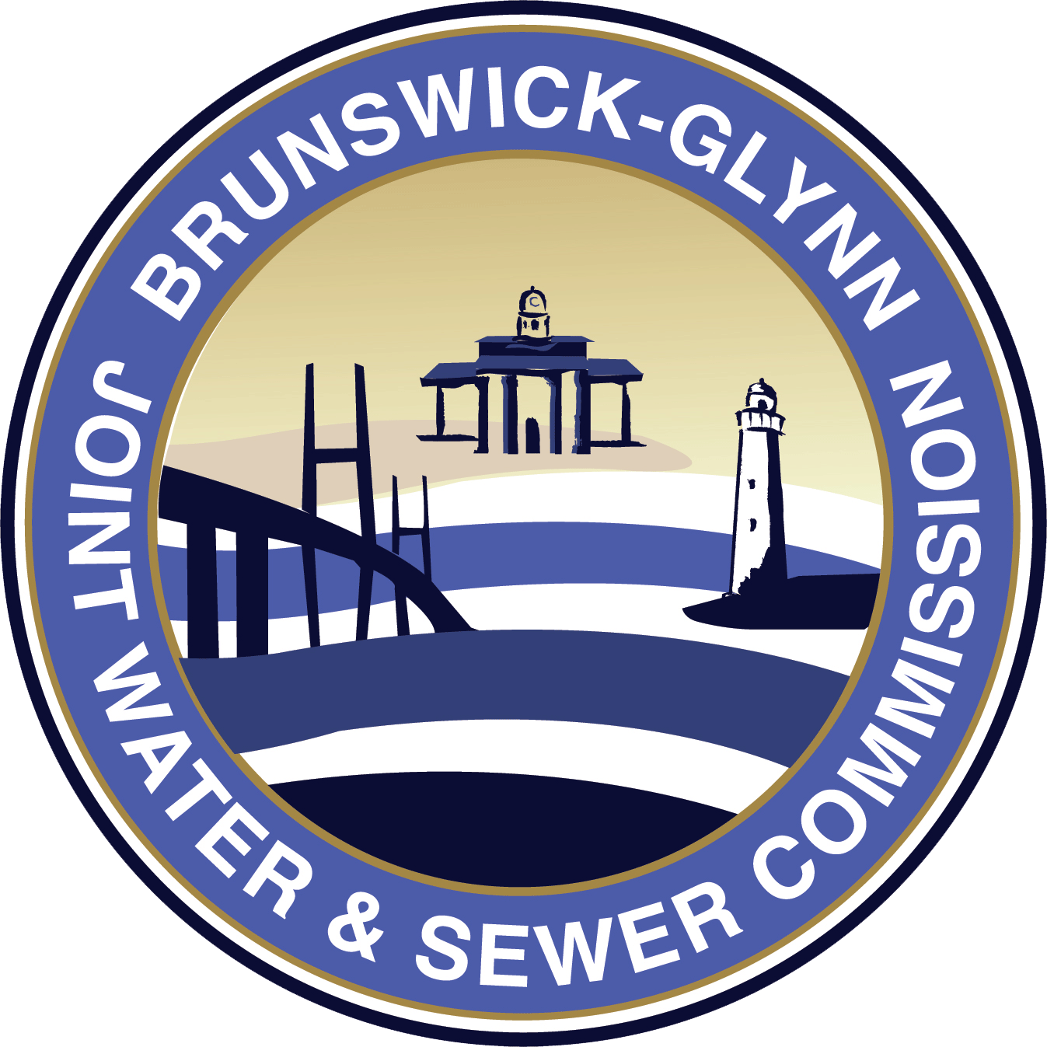

Brunswick-Glynn Joint Water and Sewer Commission
1703 Gloucester Street, Brunswick, GA 31520
Wednesday, December 15, 2021 3:00 PM
Commission Meeting Room

FINANCE COMMITTEE AGENDA

COMMITTEE MEMBERS: Finance Chairman Bob Duncan
Commissioner Chuck Cook
Commissioner Tripp Stephens
Executive Director Andrew Burroughs

PUBLIC COMMENT PERIOD
Public Comments will be limited to 3 minutes per speaker. Comments are to be limited to relevant information regarding your position and should avoid being repetitious. Individuals should sign in stating your name, address and the subject matter on which you wish to speak. Your cooperation in this process will be greatly appreciated.

APPROVAL
1. Workers’ Compensation Renewal – Jeffrey Singletary, TSI / Jarrett Bridges, Turner & Associates
2. Minutes from November 17, 2021 Finance Committee Meeting (subject to any necessary changes)
3. USGS Joint Funding Agreement – A. Burroughs
4. Low Income Housing Water Assistance Program Agreement – L. Roberts

DISCUSSION
1. Financial Statements Month End November 30, 2021 – F. Wilson

MEETING ADJOURNED

