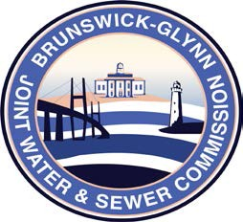

**Brunswick – Glynn**

**Joint Water & Sewer Commission**

May 24, 2021

Proposal Award

**PROJECT: RFP NO. 21-020 TOTAL COMPENSATION STUDY FOR THE BGJWSC**

At a regular meeting of the Brunswick Glynn County Joint Water & Sewer Commission on Thursday, May 20, 2021 the award for BGJWSC Project No. 21-020 Total Compensation Study for the BGJWSC was made to:

Evergreen Solutions, LLC