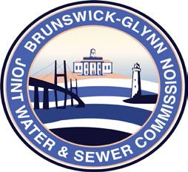

Brunswick – Glynn
Joint Water & Sewer Commission
May 24, 2021

Proposal Award

PROJECT: RFP NO. 21-018 AUTOMATIC TRANSFER SWITCHES FOR PORTABLE GENERATORS FOR THE BGJWSC

At a regular meeting of the Brunswick Glynn County Joint Water & Sewer Commission on Thursday, May 20, 2021 the award for BGJWSC Project No. 21-018 Automatic Transfer Switches for Portable Generators was made to:

Y-Delta, Inc.

