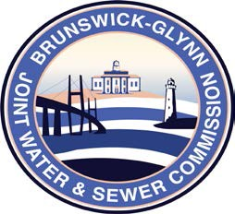

**Brunswick – Glynn**

**Joint Water & Sewer Commission**

May 26, 2020

Bid Award

**PROJECT: REQUEST FOR PROPOSAL NO. 20-029 ENGINEERING SERVICES FOR WATER AND SEWER MASTER PLAN UPDATES**

At the May 21, 2020 regular meeting of the Brunswick-Glynn Joint Water & Sewer Commission, the contract for RFP No. 20-024 Engineering Services for Water and Sewer Master Plan Updates was awarded to:

Four Waters Engineering, Inc.