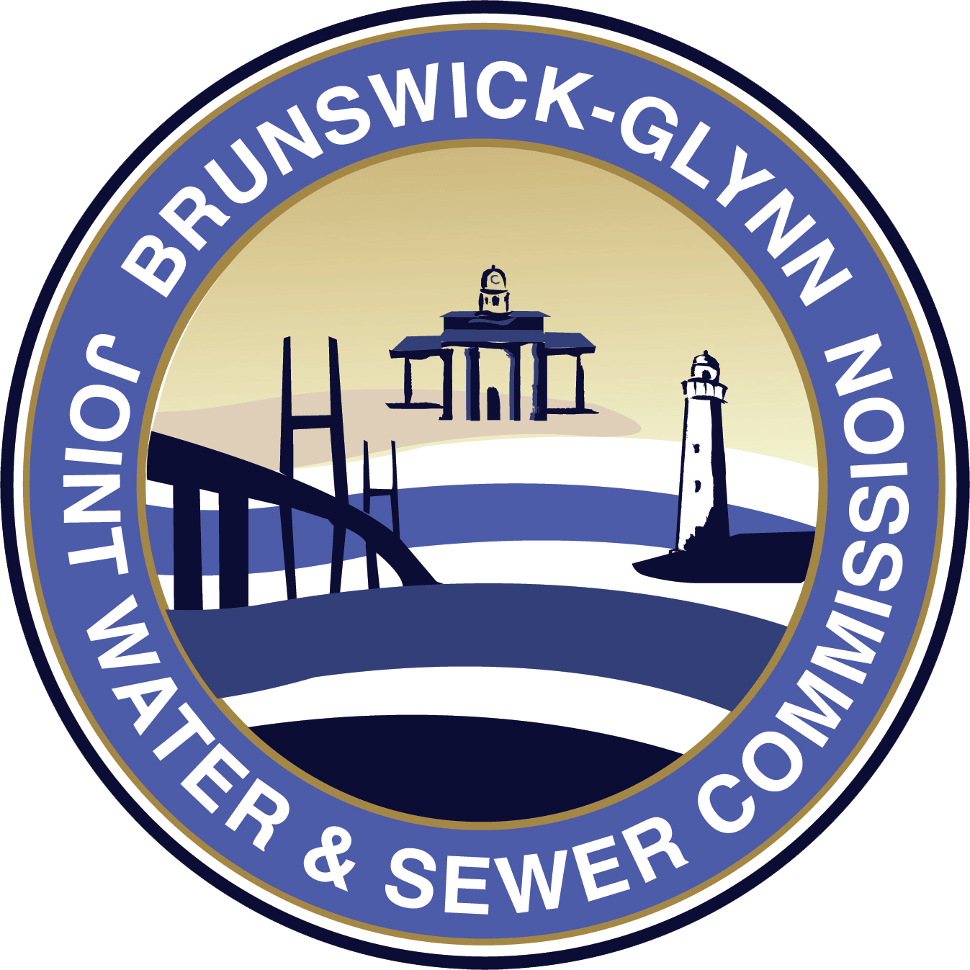

**Brunswick-Glynn County**

**Joint Water and Sewer Commission**

**May 21, 2020**

**IFB No. 20-007 Pump Station 4021 Rehabilitation and Upgrades Project**

**NOTICE OF RE-BID**

Due to changes in scope of work in the original bid package of Invitation for Bid No. 20-007 Pump Station 4021 Rehabilitation and Upgrades, the Brunswick-Glynn Joint Water & Sewer Commission has made the decision to place the solicitation out for re-bid. The solicitation will be re-bid with updated scope within thirty (30) days of this notice.

Pamela Crosby

Procurement Director

Brunswick-Glynn County Joint Water & Sewer Commission