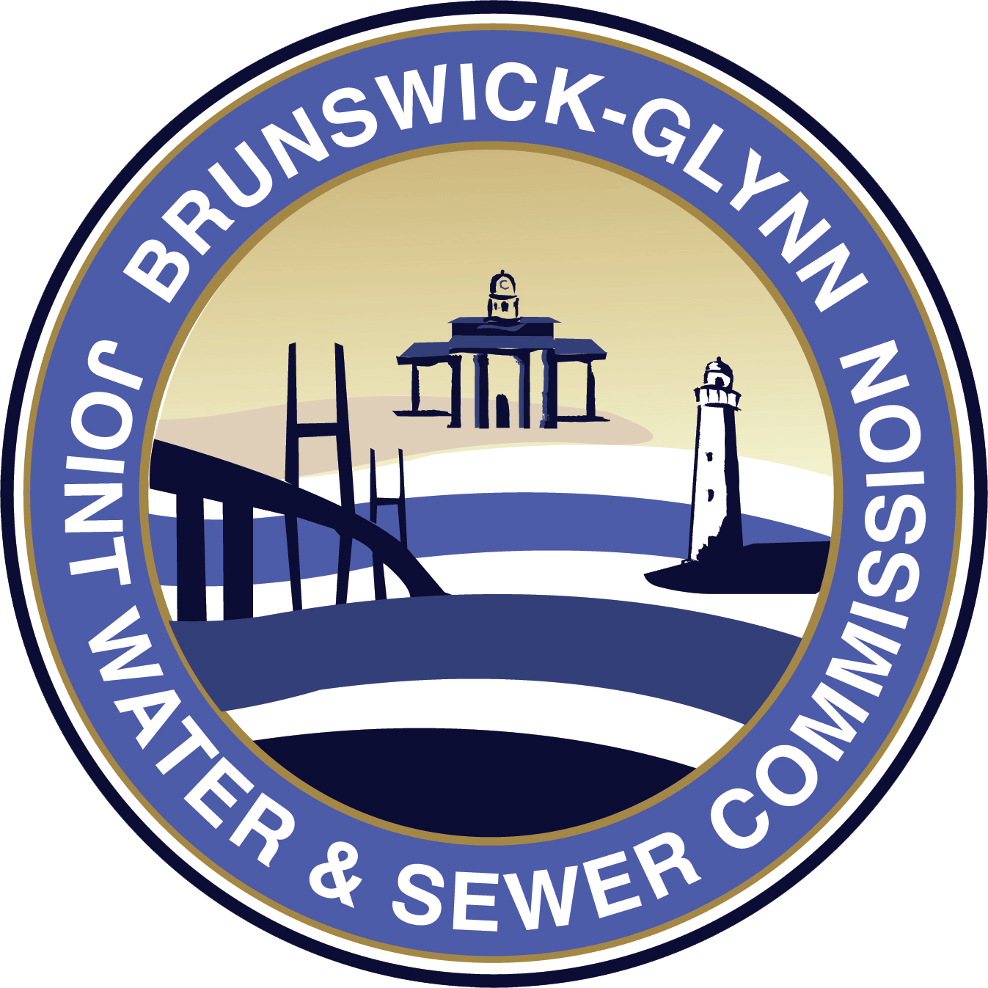

**Brunswick-Glynn County**

**Joint Water and Sewer Commission**

**July 24, 2020**

**IFB No. 20-007 Pump Station 4021 Rehabilitation and Upgrades Project**

**NOTICE OF RE-BID**

Due to changes in scope of work in the original bid package of Invitation for Bid No. 20-007 Pump Station 4021 Rehabilitation and Upgrades, the Brunswick-Glynn Joint Water & Sewer Commission has made the decision to place the solicitation out for re-bid. This solicitation has been rebid in Fiscal Year 2021 as ITB 21-001 Pump Station 4021 Rehabilitation and Upgrades. Please use the following website for all documentation and forms related to the updated project/scope, <https://www.bgjwsc.org/itb-20-001-pump-station-4021-rehabilitation-and-upgrade-project-no-904-for-the-bgjwsc/> .

Pamela Crosby

Procurement Director

Brunswick-Glynn County Joint Water & Sewer Commission