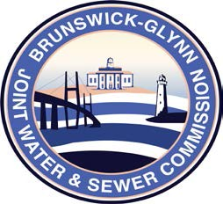

**Brunswick – Glynn**

**Joint Water & Sewer Commission**

January 8, 2020

Proposal Award

**PROJECT: REQUEST FOR PROPOSAL PURCHASE OF ONE ¾ TON SERVICE BODY TRUCK**

The BGJWSC Proposal to Provide for Purchase One (1) ¾ Ton Service Body Truck was awarded to the following:

Nalley Buick GMC Brunswick