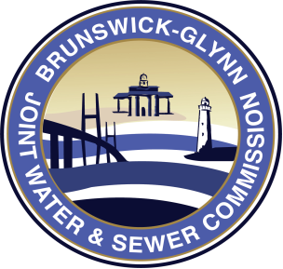

**BRUNSWICK-GLYNN COUNTY JOINT**

**WATER & SEWER COMMISSION**

November 15, 2019

**PROJECT: IFB No. 20-011 – Ridgewood Water Production Facility Project No. 417 for the Brunswick Glynn Joint Water & Sewer Commission**

**ADDENDUM: One (1)**

**DUE DATE: TUESDAY, DECEMBER 3, 2019 – 12PM, NOON**

**THIS ADDENDUM IS FOR THE PURPOSE OF MAKING THE FOLLOWING CLARIFICATIONS:**

**\*\* The due date for any questions associated with this solicitation has been extended to Tuesday, November 19, 2019 by 5:00PM. Please make sure all questions are submitted to the BGJWSC Director of Procurement, Pamela Crosby in writing via email at** [**pcrosby@bgjwsc.org**](mailto:pcrosby@bgjwsc.org) **. The due date for the solicitation remains Tuesday, December 3, 2019 by 12:00PM, Noon.\*\***



## 

**All applicants under this Invitation for Bid are kindly requested to acknowledge receipt of this Addendum in original only.**

**ACKNOWLEDGEMENT**

**ADDENDUM: ONE (1)**

**DATE:______________________**

**The above Addendum is hereby acknowledged:**

**_____________________________________________________________________________**

**(NAME OF BIDDER)**

**______________________________ _______________________________**

**Signature Title**