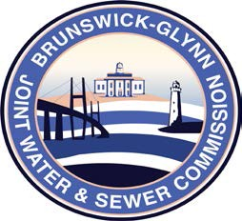

**Brunswick – Glynn**

**Joint Water & Sewer Commission**

December 31, 2019

Bid Award

**PROJECT: REQUEST FOR PROPOSAL NO. 20-002 BANKING, MERCHANT & INVESTMENT SERVICES FOR THE BRUNSWICK GLYNN JOINT WATER & SEWER COMMISSION**

At the December 19, 2019 regular meeting of the Brunswick-Glynn Joint Water & Sewer Commission, the award for the Banking and Merchant portions of RFP No. 20-002, Banking, Merchant, and Investment Services for the BGJWSC was made to:

BB&T