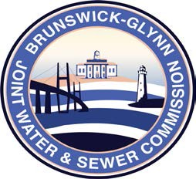

**Brunswick – Glynn**

**Joint Water & Sewer Commission**

July 30, 2019

Proposal Award

**PROJECT: REQUEST FOR PROPOSAL NO. 20-001 – PURCHASE OF ONE QUARTER TON PICKUP TRUCK FOR THE BGJWSC**

The BGJWSC Proposal to Provide for Purchase One (1) Quarter Ton Pickup Truck for the Brunswick Glynn Joint Water & Sewer Commission has been awarded to the following bidder:

Langdale Chevrolet