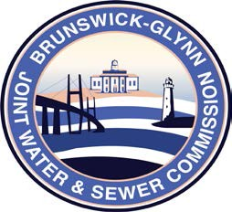

**Brunswick – Glynn**

**Joint Water & Sewer Commission**

February 7, 2019

Proposal Award

**PROJECT: RFP – ENGINEERING & DESIGN SERVICES FOR SPLOST 2016 COLLECTION SYSTEM MODIFICATIONS TO THE CITY OF BRUNSWICK LS4003 BASIN TO THE BRUNSWICK-GLYNN COUNTY JOINT WATER & SEWER COMMISSION, SOLICITATION NO. 19-006**

At a regular meeting of the Brunswick Glynn County Joint Water & Sewer Commission on Thursday, February 7, 2019 the award for BGJWSC Project No. 19-006, Engineering & Design Services for SPLOST 2016 Collection System Modifications to the City of Brunswick LS4003 Basin was made to:

Hussey, Gay, Bell, & DeYoung Consulting Engineers