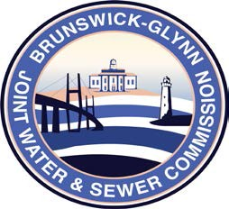

**Brunswick – Glynn**

**Joint Water & Sewer Commission**

September 28, 2018

Proposal Award

**PROJECT: SEWER REPAIRS TO MARY ROSS PARK AT F STREET & BAY STREET, SOLICITATION NO. 19-003**

The BGJWSC Invitation for Bid for Sewer Repairs to Mary Ross Park at F Street & Bay Street has been awarded to the following:

Griffin-Folsom Construction, LLC