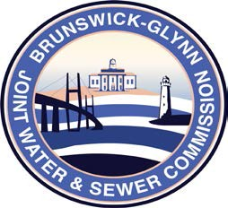

**Brunswick – Glynn**

**Joint Water & Sewer Commission**

September 28, 2018

Proposal Award

**PROJECT: REQUEST FOR PROPOSAL TO PROVIDE FOR PURCHASE ONE (1) 1/2 TON 4X2 EXTENDED CAB FORD TRUCK, SOLICITATION NO. 19-001**

The BGJWSC Proposal to Provide for Purchase One (1) 1/2 Ton 4x2 Crew Cab Truck was awarded to the following:

Mike Burch Ford of Blackshear