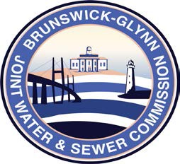

**Brunswick – Glynn**

**Joint Water & Sewer Commission**

May 18, 2018

Bid Award

**PROJECT: AUDITING SERVICES TO THE BGJWSC**

On May 17, 2018 the Brunswick-Glynn Joint Water & Sewer Commission contract for Auditing Services for FY2018 through FY2020 was awarded to the firm of:

Mauldin & Jenkins, LLP