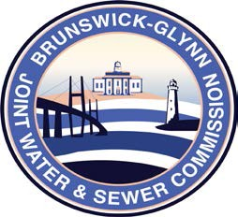

**Brunswick – Glynn**

**Joint Water & Sewer Commission**

April 18, 2018

Bid Award

**PROJECT: RFP – 4x2 Crew Cab Service Body Truck for Water Distribution Division Solicitation No. 18-010**

On April 18, 2018 the Brunswick-Glynn Joint Water & Sewer Commission contract for the purchase of one 4x2 Crew Cab Service Body Truck for Water Distribution Division, was awarded to:

Wade Ford