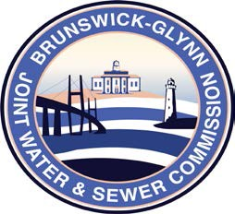

**Brunswick – Glynn**

**Joint Water & Sewer Commission**

March 20, 2018

Bid Award

**PROJECT: CCTV CAMERA INSPECTION FOR 2016 SPLOST PHASE II & III DOWNSTREAM ASSESSMENT FOR BGJWSC**

On March 20, 2018 the Brunswick-Glynn Joint Water & Sewer Commission contract for CCTV Camera Inspection for 2016 SPLOST Phase II & III Downstream Assessment was awarded to:

Blood Hound, LLC