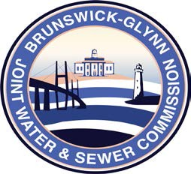

**Brunswick – Glynn**

**Joint Water & Sewer Commission**

November 21, 2017

Proposal Award

**PROJECT: REQUEST FOR PROPOSAL TO PROVIDE FOR PURCHASE ONE (1) ½ TON 4x2 EXTENDED CAB TRUCK**

The BGJWSC Proposal to Provide for Purchase One (1) ½ Ton 4x2 Extended Cab Truck was awarded to the following dealership:

**JC Lewis Ford**