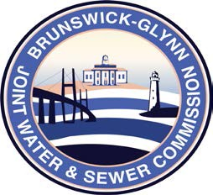

**Brunswick – Glynn**

**Joint Water & Sewer Commission**

November 7, 2017

Solicitation Award

**PROJECT: RFQ to Provide Professional Bond Counsel Services to the BGJWSC – Solicitation No. 18-004**

On November 2, 2017 at the BGJWSC Commission Meeting, the Solicitation No. 18-004 RFQ to Provide Professional Bond Counsel Services to the Brunswick Glynn Joint Water & Sewer Commission was awarded to the following:

Gray, Pannell, & Woodward, LLP