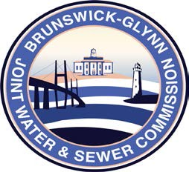

**Brunswick – Glynn**

**Joint Water & Sewer Commission**

September 26, 2017

Bid Award

**PROJECT: Sanitary Sewer Flow Monitoring**

On September 21, 2017 at the BGJWSC Commission Meeting, the BGJWSC Project – Sanitary Sewer Flow Monitoring was awarded to the following:

McKim & Creed