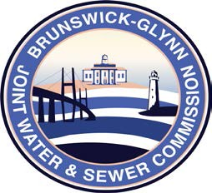

**Brunswick – Glynn**

**Joint Water & Sewer Commission**

May 23, 2017

Bid Award

**PROJECT: Lift Station 4048 Force Main Improvements Project No. 701**

On May 18, 2017 at the BGJWSC Commission Meeting, the BGJWSC Project –Lift Station 4048 Force Main Improvements Project No. 701 was awarded to the following:

TB Landmark Construction, Inc.